**Assignment_3**

**====================================================================**

**Name:** Ahmed Nour

**Sheet ID:** 16

**Email:** [**ahmedmohamednoour@gmail.com**](mailto:ahmedmohamednoour@gmail.com)

**====================================================================**

**Q1)**

**Main Code:**

**Do file:**

**Testbench code:**

**Simulation:**

**Linting:**

**Q2)**

**TFF Golden model code:**

**DFF Golden model code:**

**Main code:**

**TFF testbench:**

**TFF do file:**

**DFF testbench:**

**DFF do file:**

**TFF simulation:**

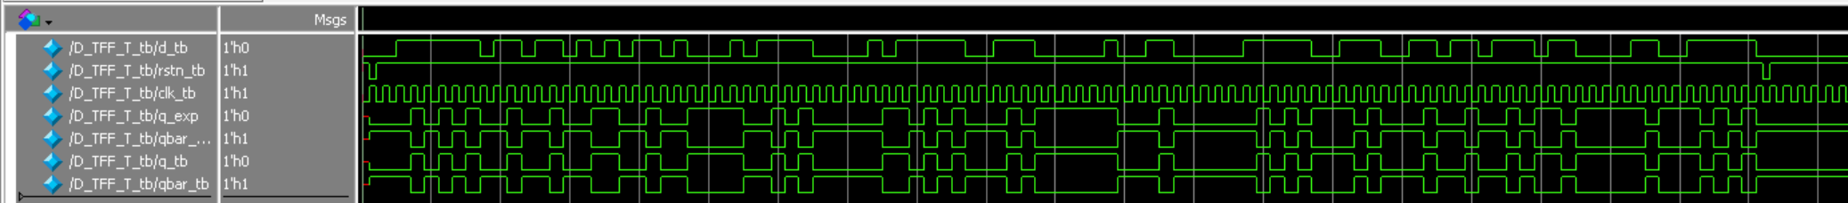

**DFF simulation**

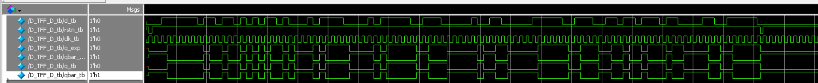

**TFF lint:**

**DFF lint:**

**Q3)**

**Main code:**

**Do file:**

**Testbench code:**

**Simulation:**



**Lint:**

**Q4)**

**DFF code:**

**Counter code:**

**Counter testbench code:**

**Do file:**

**Simulation:**



**Lint:**

**Schematic:**

**Q5)**

**Register code:**

**Do file:**

**Testbench code:**

//rest of code in next page:

**Simulation:**

**Lint:**

**Schematic:**

**Q6)**

**SLE code:**

**Do file:**

**Testbench code:**

**Simulation:**

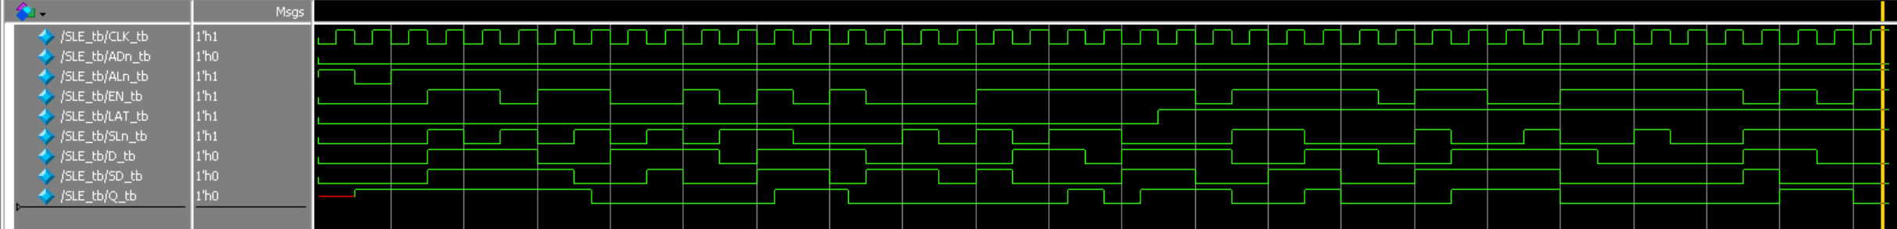

**Lint:**

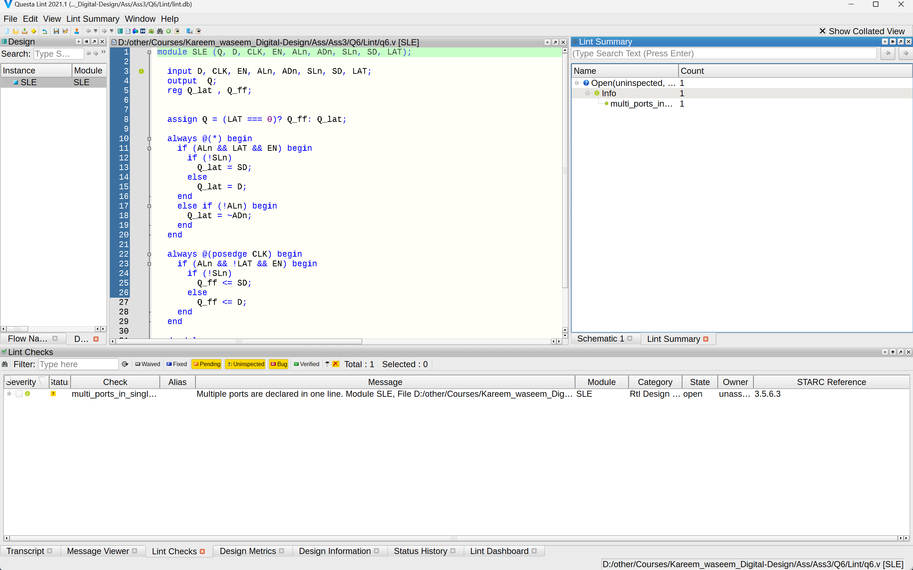

**Schematic:** 